CHAPTER 8: The dynamic Earth
© MAPgraphics Pty Ltd, Brisbane
Worksheet 8.1

Continental drift
Student: Class:

Two hundred million years ago
1. The map below shows the continents as they were 200 million years ago.
(a) Identify the name of the supercontinent that existed 225 million years ago before it broke up into Laurasia and Gondwana.
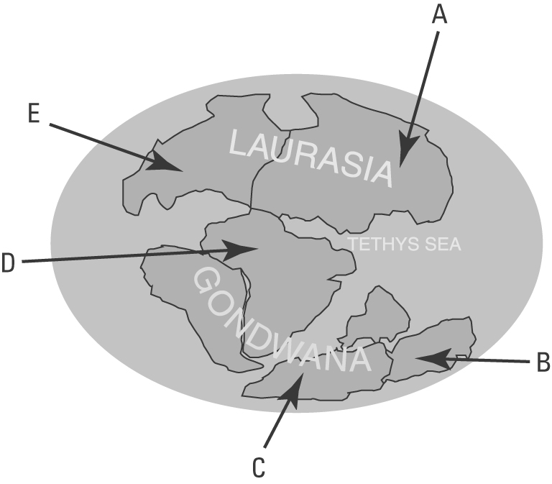 | (b) Identify the name of the continents of today that are labelled with the letters A–E.  A:  B:  C:  D:  E:
(c) Fossils of a fern called Glossopteris have been found in the locations marked on the map below.
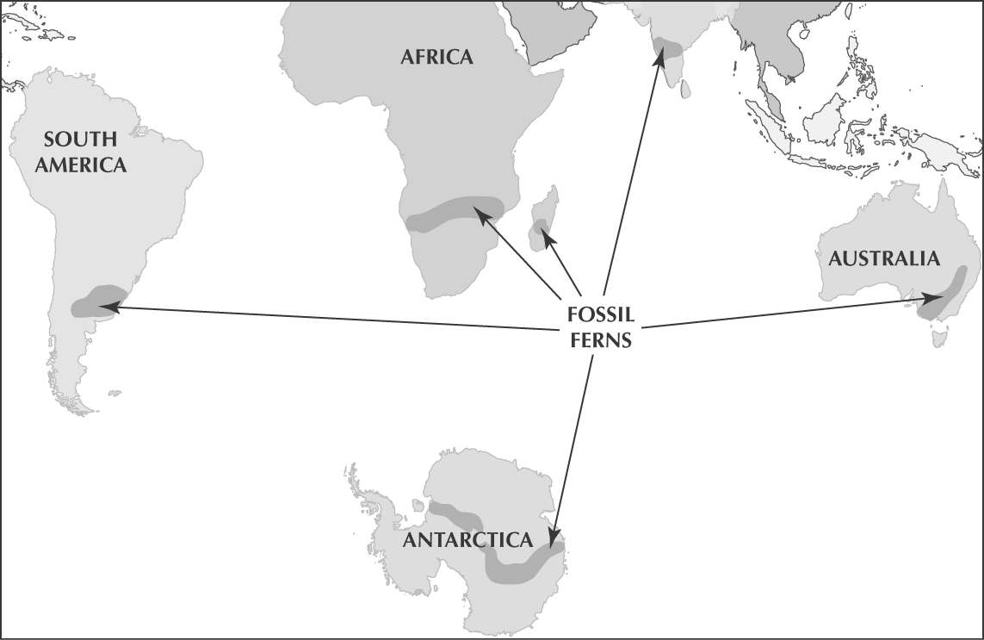 | Explain how scientists use this information to support the theory of continental drift.

Alfred Wegener
2. During the late 1800s and early 1900s, scientists collected evidence that indicated that the continents were moving. In 1912, Alfred Wegener made a number of observations about continental drift.
(a) Explain what Wegener noticed about the shapes of coastlines of various continents such as Africa and South America.

(b) Explain how fossils and rock types supported Wegener’s theory.

